**TASK 8**

Write a C program to perform the following file operations:

Open an existing file named "data.txt." If it doesn't exist, the program should create it.

Write the string "Hello, File Handling in C!" to the file.

Move the file pointer to the beginning of the file and read the contents back.

Print the contents read from the file to the console.

Close the file.

**CODE**

#include <stdio.h>

#include <stdlib.h>

int main() {

FILE *fp;

char buffer[100];

// Open the file in write+read mode. Create if it doesn't exist.

fp = fopen("data.txt", "w+");

if (fp == NULL) {

perror("Error opening file");

return 1;

}

// Write to the file

fputs("Hello, File Handling in C!", fp);

// Move file pointer to the beginning

rewind(fp);

// Read contents back

fgets(buffer, sizeof(buffer), fp);

// Print to console

printf("File Content: %s\n", buffer);

// Close the file

fclose(fp);

return 0;

}



**DATA**

Hello, File Handling in C!



**OUTPUT & SCREENSHOTS---**

**01).**

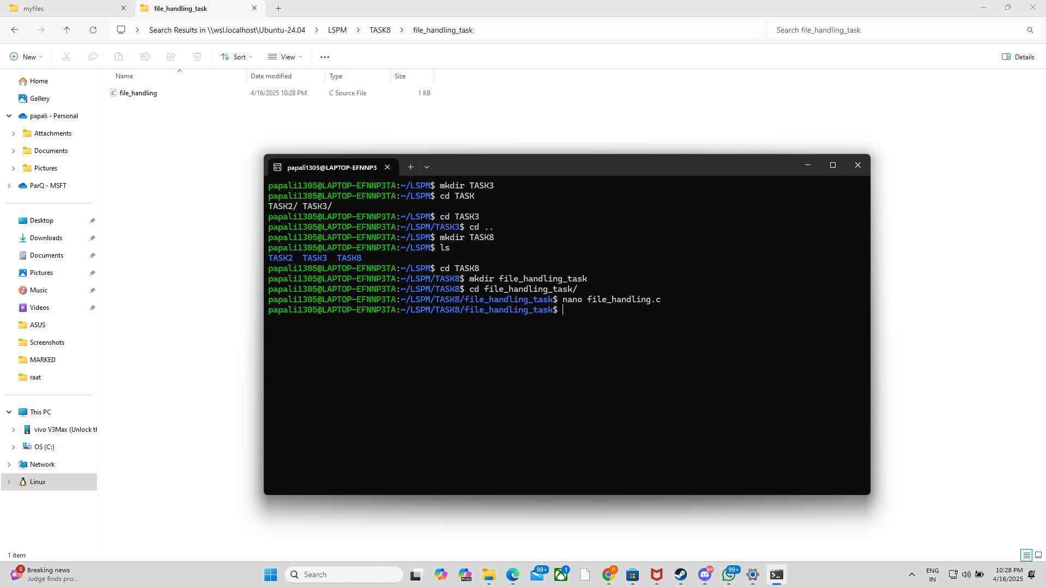

**02).**

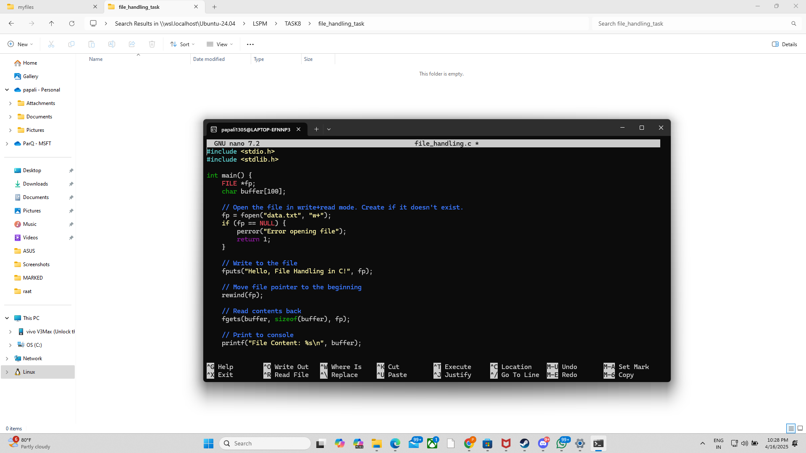

**03).**

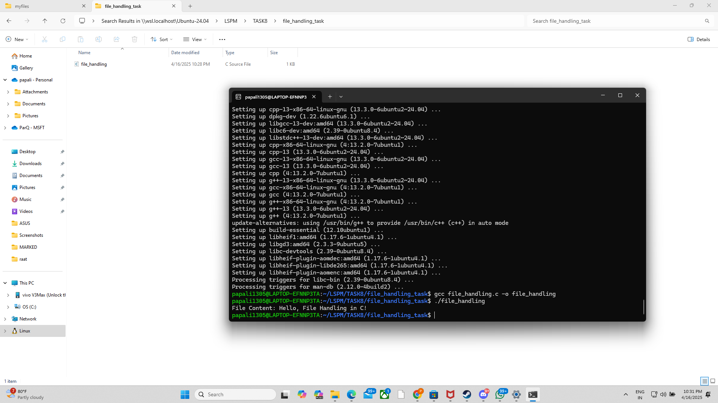

**04).**

